## 2025-2026: FORM 1

**Diocese of Worcester - SAFE ENVIRONMENT CURRICULUM School Report**

# STUDENTS

**School**

**City**

|  |  |  |  |  |
| --- | --- | --- | --- | --- |
| **Grade** | **Potential #** | **#Completed** | **#Absent** | **# Opt Out** |
| **K** |  |  |  |  |
| **1** |  |  |  |  |
| **2** |  |  |  |  |
| **3** |  |  |  |  |
| **4** |  |  |  |  |
| **5** |  |  |  |  |
| **6** |  |  |  |  |
| **7** |  |  |  |  |
| **8** |  |  |  |  |
| **9** |  |  |  |  |
| **10** |  |  |  |  |
| **11** |  |  |  |  |
| **12** |  |  |  |  |

Signature/Title Date

**Due:** February 6, 2026

### DIOCESE OF WORCESTER

#### SAFE ENVIRONMENT CURRICULUM

**School Report**

# PARENTS

## 2025-2026

### Form 2

**School**

**School City**

|  |  |
| --- | --- |
| **Date** | **Number** |
|  |  |
|  |  |
|  |  |
|  |  |
|  |  |
|  |  |
|  |  |
|  |  |

Signature/Title Date

Due: February 6, 2026

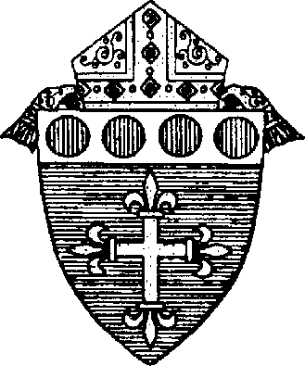DIOCESE OF WORCESTER 2025-2026

#### SAFE ENVIRONMENT CURRICULUM FORM 3

**School Report**

Each grade’s curriculum was designed to meet the overall program objectives. Please review your leaders’ evaluations. Based on this review, has the program adequately met these overall objectives?

1. Children/young people will understand they are created by God and live in the love of the Father, Son, and Holy Spirit.
2. Children/young people will be able to describe the *Circle of Grace* that God gives each of us.
3. Children/young people will be able to identify and maintain appropriate boundaries.
4. Children/young people can identify types of boundary violations.
5. Children/young people will demonstrate how to take action if a boundary is threatened or violated.

#### YES NO

|  |  |
| --- | --- |
| **Grade 3 (tally of leader’s evaluation)** | |
| Number of children who got 70% or better on their pre-assessment |  |
| Number of children who got below 70% on their pre-assessment |  |
| Number of children who got 70% or better on their post-assessment |  |
| Number of children who got below 70% on their post-assessment |  |
| **Grade 6 (tally of leader’s evaluation)** |  |
| Number of children who got 70% or better on their pre-assessment |  |
| Number of children who got below 70% on their pre-assessment |  |
| Number of children who got 70% or better on their post-assessment |  |
| Number of children who got below 70% on their post-assessment |  |
| **Grade 9 (tally of leader’s evaluation)** |  |
| Number of children who got 70% or better on their pre-assessment |  |
| Number of children who got below 70% on their pre-assessment |  |
| Number of children who got 70% or better on their post-assessment |  |
| Number of children who got below 70% on their post-assessment |  |

Your feedback is very important in making *Circle of Grace* the best program possible for our children and young people. You may summarize your leader comments or send us their original evaluations. **On a separate sheet**, please list

* + what worked well and any resources you would like to share
  + any suggestions that would improve the program

Signature: Date:

**School:**

Please send to: Office of Religious Education, 49 Elm St., Worcester, MA 01609

or FAX (508) 753-7180, or email to: [tromeo@worcesterdiocese.org](mailto:tromeo@worcesterdiocese.org) **DUE: February 6, 2026**